AN INTRODUCTION TO BRAMFORD PRE-SCHOOL PLAYGROUP

We are a small village based pre-school, educating approximately sixty children in a school year, with a maximum of 33 children per session. Our playgroup is open to any child from the age of 2 years old up until the compulsory school age.

The playgroup was established in 1969, originally in the village hall, moving to our current location in 1975. Throughout this time we have seen many changes but one thing has remained the same - we are continually committed to providing the best educational opportunities for young generations in the best learning environment.
We feel privileged to be based in a village that is very community minded and believe that our service still offers excellent opportunities for young people to develop in all areas. Our friendly, enthusiastic and qualified staff are dedicated in providing an inclusive environment for all children that attend.

We offer mixed age sessions, mornings and afternoons, Monday to Friday.
Breakfast, after school and holiday sessions are also offered subject to availability.
We accept 2 year old, Universal and Extended Government funding as well as Tax-free Childcare.
(Further information can be found on the ‘Childcare Choices’ website).
Funding can be used for payment of sessions and/or lunch club.

Staff/child ratios are strictly adhered to. 1:4 for 2 year olds and 1:8 for 3 and 4 year olds.

OUR ETHOS

At Bramford Pre-school Playgroup, we are dedicated to providing individual care and education for children.

We pride ourselves on our ability to provide high quality childcare and education, appropriate to their individual needs.

We aim to offer a warm and nurturing environment in which each child can flourish and reach their full potential.

We endeavour to support every child in our care in order to ensure that they achieve their upmost, develop confidence in their own abilities and a lifetime love of learning.

We recognise the importance of good manners and respect for others and believe that this in itself enables our children to be well prepared for life outside the setting.

We are dedicated to providing the children in our care a strong foundation for life and believe that a quality Early Years education affords children with the best opportunity to achieve their full potential, both while at the setting and in the future.

By focusing on children’s strengths, passions and interests, our staff can develop an insight into that child’s potential as they flourish. Ensuring that appropriate activities are planned in order to promote and celebrate these abilities.

EYFS CURRICULUM

The EYFS provides the curriculum framework that we will build upon when deciding what we intend children to learn and develop.
We will work with parents and carers when deciding how to implement the curriculum to enable children to progress in the seven areas of learning.

The Seven areas are:

PRIME AREAS
- Personal, Social and Emotional Development
- Communication and Language
- Physical Development

SPECIFIC AREAS
- Literacy
- Maths
- Understanding the World
- Expressive Arts and Design
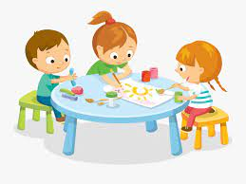

To implement this we will have:
- Practitioners that understand child development
- An enabling environment where children can play and learn
- High quality meaningful interactions
- Adults who listen to children and have conversations with them
- A balance between child lead and adult guided learning experiences
- A flexible approach so that we can adapt what we offer and do so to meet the individual needs of all children
- An understanding of how to develop the characteristics of effective learning

Our practitioners will regularly check that children are secure in what they have learnt and give them plenty of time for enjoyment and practice by:
- Staff being flexible, allowing children’s interests to drive their learning
- Providing depth in areas, as this is more important than covering lots of things in a superficial way
- Providing opportunities in guided playful learning and direct teaching

When assessing children, it is more about noticing what children can do and what they know. It is not about lots of data and evidence; this allows our staff to interact more with the children.
We will support each child and provide extra support where needed.

All children will have a two year check, a development record the term after they turn three and also the term after they turn four, unless a Summer born child where a report will be completed before they go on to school or their next setting.

WELCOME TO OUR PLAYGROUP

Our Committee/Fundraising

We are a community playgroup run by a committee that is elected each November at our AGM.
Our playgroup is a registered member of the Pre-School Learning Alliance and is a non-profit making charitable organisation, which is run separately from Bramford Primary School. The playgroup is overseen by a committee of dedicated parents/carers, who help to maintain the smooth running and professionalism of our service.
The committee is responsible for organising the many fundraising events that we hold throughout the year to help maintain our income. We are always pleased to see all parents/carers and children supporting these. Some of the annual events we hold are an Easter Social, Photographic Session, Pamper Evening, Quiz Night and Christmas Social.
However, we continuously aim to provide a variation of other fundraising events to accompany these. Watch out for further details on the notice board in the entrance hall of the playgroup.
We welcome new parents/carers to the committee. If you feel that you would like to give us a little bit of your time (and we very much hope you can) please feel free to speak to any member of staff or existing committee member. They will happily explain in more detail about positions that need to be filled, meeting times etc.

Assessments
In addition to your 2 year old health visitor appointment, the pre-school will also complete a development check at this time. To ensure that your child’s individual needs are being met appropriately, further development records are made the term after your child’s 3rd and 4th birthday. This information will then be passed on to your chosen primary school.

Observations of your child’s development will be available to view on Tapestry.
Parent evenings are held throughout the school year. This is an ideal opportunity to meet with your child’s key worker.

SAFEGUARDING
Our Child Protection Statement

Bramford Pre-School Playgroup is here to serve children and families. We will listen and keep private anything you to say to us. However, we have to inform the child protection agencies if we are worried about the care a child is receiving. Our Safeguarding Officer is Mrs Tracy Simpson.

Safeguarding Children Policy

Bramford Pre-School Playgroup intends to create a pre-school which offers a safe environment from abuse and in which if there is any suspicion of abuse it is dealt with promptly and appropriately. In order to achieve this we will exclude known abusers, seek and supply training, prevent abuse by means of good practice, respond appropriately to suspicions of abuse, keep records and liaise with other bodies.
Our safeguarding co-ordinator is Mrs Simpson, assisted by Mrs Thompson.

SPECIAL EDUCATIONAL NEEDS
Our Special Needs Statement
Bramford Pre-School Playgroup is here to offer fully inclusive sessioal care to all children.
We aim to provide an environment that supports the needs of individual children; this may include liaising with outside agencies to ensure that we offer the best opportunities.
As a playgroup we welcome children from all backgrounds and all abilities and work closely with parents to meet the children's individual needs.
Our Special Educational Needs Co-ordinator (SENDCO) is Mrs Thompson, assisted by Mrs Simpson
It is the role of the SENDCO to ensure that playgroup meets the aims and objectives of our Special Educational Needs Policy, which is available for all to view should more information be required on this.

Working in Partnership with Parents/Carers

Parents and carers play a valuable part in our playgroup life and we wish to encourage them to be actively involved in this partnership wherever possible. It is the aim of Bramford Pre-School Playgroup to work in partnership with the parents/carers of all children who attend the setting and to ensure that all staff communicates information positively, confidentially and effectively.
We use the ‘ParentMail’ system, that allows us to communicate via text and email to parents, but for this to work effectively we ask that parents keep us up to date with any changes to their contact information.
The playgroup also uses Tapestry, an online record of your child’s experiences, development and learning journey during their time with us. Parents can view photographs, videos and diary entries as well as upload their own comments and media.
We also have our own closed group Facebook page.

All staff have attended the Suffolk County Council’s ‘Conversations with Parents/Carers’ course.

We aim to ensure that there is equal access to all children and that our facilities and services are available to them and their parents/carers. Dealing effectively with parental complaints within our setting is important to us. As soon as a complaint is made to a member of staff, either verbally or written, we will endeavour to resolve the matter as soon as possible. If parents feel that the complaint hasn't been dealt with to their satisfaction they are obliged to inform the chairperson who will then endeavour to address the complaint in the best possible way.

Working in partnership with Bramford Primary School
Social development plays a key role at playgroup, as it is the basis for children to form friendships and strong relationships with each other and to enable them to start school life as a united group.
To help ensure this smooth transition further, we pride ourselves on our very close working relationship with Bramford Primary School. Throughout your child's time at playgroup there will be many opportunities for them to visit the school and participate in their school events. We recognise the importance of our older children being given the opportunity to do this regularly; therefore we create as many opportunities for this as possible. PE sessions are held in the school hall every Monday morning for our four year olds. This gives the children the chance to become familiar with the school environment and encourage them to become independent dressing and undressing themselves.

All children attend Easter and Harvest assemblies, watch a variety of the children's plays and attend story time sessions in the reception class.
An annual sports afternoon is held on the school field for all of our children and their families to attend.
We also visit the Methodist Church and Cherryfields throughout the year. These visits help integrate the children into village life.
IMPORTANT INFORMATION
Fees/Funding
Fee invoices will be issued half termly in advance with a due date clearly indicated. This invoice will include a snack charge of £6.
Payments made after the due date may incur a penalty.
When paying fees by cheque could you please ensure that it is payable to ‘Bramford pre-school playgroup’ and that your banker’s card number is written on the reverse.
It is important to note that no refunds will be given for any period of absence (including holidays, sickness and circumstances beyond our control).
Fees are subject to review at regular intervals.
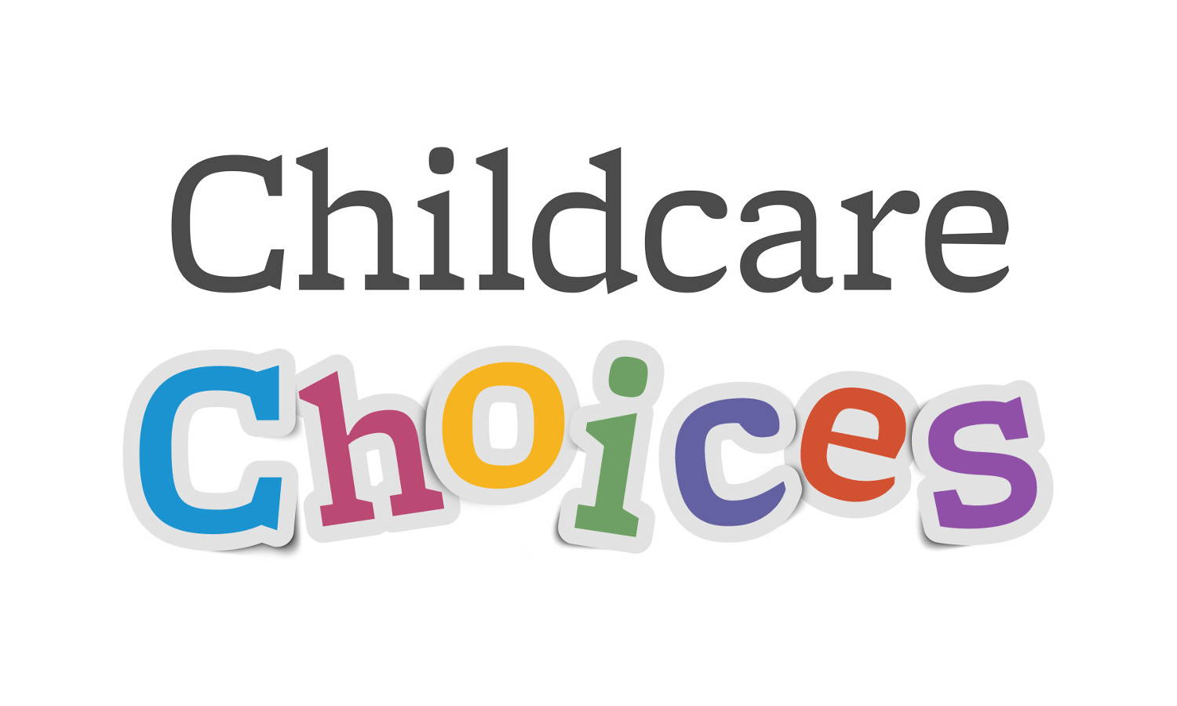
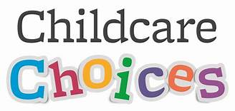
We accept the following Government funding:

Universal funding - available to all children the term after they turn three, currently 15 hours per week.

Extended Funding (also known as 30 hours) – this entitles your child to an additional 15 hours per week, should you meet the eligibility criteria (3 and 4 year olds only).

2 year old funding - If you are eligible for funding you will receive 15 hours per week.

Tax-free Childcare – for every £8 you pay into an account the Government will add £2 (up to a total of £2000).

Funding can be used for sessions and/or lunch clubs, should you wish for your child to attend a full day.

Further information on funding eligibility can be found on the ‘childcare choices’ website.

Please note that an eligibility code for ’30 hours’ funding needs to be obtained from the Childcare Choices website and given to the playgroup THE TERM BEFORE you wish to use the funding.

Use of funding is subject to session availability.
Medical Procedures and Policy
It is the aim of Bramford Pre-School Playgroup to be fully aware of any medical conditions a child may have when starting with us. We will liaise carefully with parents/carers to ensure that all information that is received is informative, appropriate and up to date.
Upon admission to playgroup parents/carers are asked to complete an admissions form, on which they must inform us if their child has an identified medical condition. Any information provided will remain confidential.
All staff are trained in Paediatric First Aid.

Allergies and Illness
Parents/Carers must inform playgroup of any allergies or health problems their child may have.
If your child is unwell we ask that they be kept at home until fully recovered. This also extends to a child who been given paracetamol/ibuprofen on the day attending playgroup.
If a child has suffered from sickness and diarrhoea we ask that 48 hours recovery is given after the child's last episode and before returning to playgroup.
If unsure of any illness or period of recuperation a medical chart is displayed on the parent/carer notice board to indicate this.

Covid-19
Please follow the current government guidance in relation to procedures regarding symptoms of Covid-19

We would also ask that you notify us if your child is to be absent from a session.
If your child is injured or becomes unwell whilst at playgroup they will be tended to by qualified first aiders. Should we have cause for concern you will be informed immediately (please ensure that all emergency contact numbers are kept up to date for this to happen effectively).
All accidents or incidents will be documented and you will be asked to sign these on collecting your child.

Health and Hygiene
Bramford Pre-School Playgroup encourages a healthy lifestyle to a high standard in its day-to-day work with the children. This is achieved by ensuring that all snacks provided at the playgroup will be nutritious and attention will be paid to children's particular dietary requirements.
When cooking as an activity, adults will provide healthy wholesome food, promoting and extending the children's understanding and recognising the importance of a balanced diet, introducing them to a variety of foods.
We would also encourage parents to continue to promote a healthy lifestyle, by providing their child with a varied healthy lunch.
Children will have outside play each session and our large canopy at the rear of the building allows this come rain or shine.
All staff hold a current food safety certificate.

Collection of Children
It is the aim of Bramford Pre-School Playgroup to ensure that the safety and security of the children is paramount at all times.
Upon admission to playgroup parents/carers are required to provide a password that is unique to them. If any other adult is to collect a child, we must be informed at the beginning of the session, if this is not known at the beginning of the session please phone playgroup as soon as possible on 01473 740782. We cannot allow a child to leave the premises without prior consent. In the situation of an unknown adult collecting the child the password has to be stated before entering the setting.
Uncollected Children
If a password cannot be provided or a child is uncollected we will use emergency contact numbers to contact the parent/carer.
If after a period of 15 minutes, the child remains uncollected and we have been unsuccessful in making contact with their parent, the police will be notified as per our policy.

ALL OUR POLICIES ARE AVAILABLE TO READ IN FULL SHOULD
FUTHER INFORMATION BE REQUIRED

